Many people have contributed in bringing this job training report in its present form I take this opportunity to thank all of them for their guidance co-ordinators.

I would like to express sincere gratitude to …………………….for his gentle support and generating a deep interest in my studies.

And also to Prof. ……………….for his tips & tricks towards completing this report.

Incredibly huge thanks to ………………… who deserves a special mention for his kind support and help in the computer lab. and also for his valuable tips & tricks.

………………………. (Lab. In charge) deserves a special mention for kind support and help in the computer lab.

Preface

Every professional course requires some practical knowledge besides the theoretical study. A bachelor of Information Technology is one important professional course it need some practice training we did in.

This project report title “ONLINE RESERVATION” with the Particular reference to ………… under the guidance of ……….. has been prepared to submitted in ……………. use were able to perform it.

REPORT OF HOME PROJECT

ON
“ONLINE RESERVATION”
(IN JAVA)

A REPORT SUBMITTE INPARTIAL FULLFILLMENT FOR
THE REQUIRMENT FOR THE AWARD IN
B. Sc (INFORMATION TECHNOLOGY)

INDEX

Contents page no

- Hardware and Software Requirement 10

- Source Codes 11 to 35

- Forms 36 to 44

HARDWARE REQUIRMENT

1. A Computer system with Intel Pentium-2 or higher.
2. A Dot-matrix or Inkjet printer.

SOFTWARE REQUIRMENT

1. Microsoft Windows 98/XP/2000/Higher.
2. Installed JDK1.3(kre & jsdk2).
3. Installed Microsoft Office XP professional Edition Microsoft
Access.
4. Installed Printer driver.
5. Installed VGA driver.
6. Screen resolution to set at 800/600.
SOURCE CODE

SOURCE CODES

Welcome Screen

import java.awt.*;
import javax.swing.*;
class Welcome implements Runnable
{
JFrame f;
JLabel l1,l2,l3;
Thread t;
Login l;
ImageIcon img;
Welcome()
{
img=new ImageIcon("indian-rail.jpg");
t=new Thread(this);
f=new JFrame("Welcome");
f.getContentPane().setLayout(null);
f.getContentPane().setBackground(Color.yellow);
l1=new JLabel("OnLine Reservation");
l1.setBounds(250,300,900,50);
l1.setFont(new Font("Courier new",Font.BOLD,60));
l1.setForeground(Color.red);
l2=new JLabel(" _By Dushmanta Pradhan");
l2.setFont(new Font("Courier new",Font.BOLD,35));
l2.setBounds(350,380,800,40);
l2.setForeground(Color.red);
l3=new JLabel(img);
l3.setBounds(0,0,1300,1000);
f.getContentPane().add(l1);
f.getContentPane().add(l2);
f.getContentPane().add(l3);
f.setSize(1300,1000);
f.setVisible(true);
t.start();
}
public void run()
{
int x=1;
while(x<=5)
{
try
{
Thread.sleep(1000);
}
catch(Exception e)
{}
x++;
}
f.setVisible(false);
l=new Login();
}
}
Login Screen

import java.awt.*;
import java.awt.event.*;
import javax.swing.*;
class Login implements ActionListener
{
JFrame f;
JLabel l1,l2;
JTextField t1;
JPasswordField t2;
JButton b1,b2;
Main M;
Login()
{
f=new JFrame("Login");
f.getContentPane().setLayout(null);
f.getContentPane().setBackground(Color.pink);
l1=new JLabel("User Name");
l1.setForeground(Color.yellow);
l1.setBounds(50,50,100,30);
l2=new JLabel("Password");
l2.setForeground(Color.yellow);
l2.setBounds(50,80,100,30);
t1=new JTextField(10);
t1.setForeground(Color.blue);
t1.addActionListener(this);
t1.setBounds(150,50,100,30);
t2=new JPasswordField(10);
t2.setForeground(Color.blue);
t2.setEchoChar('*');
t2.addActionListener(this);
t2.setBounds(150,80,100,30);
b1=new JButton("Ok");
b1.setForeground(Color.blue);
b1.addActionListener(this);
b1.setBounds(50,120,100,30);
b2=new JButton("Cancel");
b2.setForeground(Color.blue);
b2.addActionListener(this);
b2.setBounds(180,120,100,30);

b1.setMnemonic('O');
b2.setMnemonic('C');

f.getContentPane().add(l1);
f.getContentPane().add(l2);
f.getContentPane().add(t1);
f.getContentPane().add(t2);
f.getContentPane().add(b1);
f.getContentPane().add(b2);
f.setBounds(300,300,300,200);
f.setResizable(false);
f.setVisible(true);
}
public void actionPerformed(ActionEvent e)
{
if(e.getSource()==b1)
{
if(t1.getText().length()==0||t2.getText().length()==0)
{
JOptionPane.showMessageDialog(null,"Fields are empty");
}
else if(t1.getText().equals("dush") && t2.getText().equals("1234"))
{
f.setVisible(false);
M=new Main();
}
else
{
JOptionPane.showMessageDialog(null,"Invalid User Name or Password");
}
}
if(e.getSource()==b2)
{
f.setVisible(false);
System.exit(0);
}
}
}

Main Screen

import java.awt.*;
import java.awt.event.*;
import javax.swing.*;
class Main implements ActionListener
{
JFrame f;
JButton b1,b2,b3,b4;
Reservation r;
Enquiry q;
Cancellation c;
JLabel imgL;
ImageIcon img;
Main()
{
img=new ImageIcon("Indian-Railway-Network.jpg");
imgL=new JLabel(img);
imgL.setBounds(0,0,1300,1000);
f=new JFrame("Main");
f.getContentPane().setLayout(null);
f.getContentPane().setBackground(Color.green);
b1=new JButton("Reservation Form");
b1.addActionListener(this);
b1.setBounds(150,390,210,60);
b2=new JButton("PNR-enquiry");
b2.addActionListener(this);
b2.setBounds(150,490,210,60);
b3=new JButton("Cancellation Form");
b3.addActionListener(this);
b3.setBounds(580,390,210,60);
b4=new JButton("Exit");
b4.addActionListener(this);
b4.setBounds(580,490,210,60);

b1.setBackground(new Color(100,200,0));
b1.setForeground(new Color(255,255,255));
b2.setBackground(new Color(100,200,0));
b2.setForeground(new Color(255,255,255));
b3.setBackground(new Color(100,200,0));
b3.setForeground(new Color(255,255,255));
b4.setBackground(new Color(100,200,0));
b4.setForeground(new Color(255,255,255));

b1.setMnemonic('R');
b2.setMnemonic('P');
b3.setMnemonic('C');
b4.setMnemonic('E');

f.getContentPane().add(b1);
f.getContentPane().add(b2);
f.getContentPane().add(b3);
f.getContentPane().add(b4);
f.getContentPane().add(imgL);
f.setSize(1300,1000);
f.setVisible(true);
}
public void actionPerformed(ActionEvent e)
{
if(e.getSource()==b1)
{
f.setVisible(false);
r=new Reservation();
}
if(e.getSource()==b2)
{
f.setVisible(false);
q=new Enquiry();
}
if(e.getSource()==b3)
{
f.setVisible(false);
c=new Cancellation();
}
if(e.getSource()==b4)
{
f.setVisible(false);
System.exit(0);
}
}
public static void main(String args[])
{
new Main();
}
}
Reservation Screen

import java.awt.*;
import java.awt.event.*;
import java.sql.*;
import javax.swing.*;
class Reservation extends Connect implements ActionListener,FocusListener
{
JFrame f;
JLabel l1,l2,l3,l4,l5,l6,l7,l8,l9,l10,l11,l12,l13;
JTextField t1,t2,t3,t4,t5,t6,t7;
Choice h;
JTextArea ta;
JButton b1,b2,b3;
PreparedStatement ps;
Statement st;
ResultSet rs;
int x;
JLabel imgL;
ImageIcon img;
void disable()
{
t1.setEnabled(false);
t2.setEnabled(false);
t3.setEnabled(false);
t4.setEnabled(false);
t5.setEnabled(false);
t6.setEnabled(false);
t7.setEnabled(false);
h.setEnabled(false);
b2.setEnabled(false);
}
void enable()
{
t1.setEnabled(true);
t2.setEnabled(true);
t3.setEnabled(true);
t4.setEnabled(true);
t5.setEnabled(true);
t6.setEnabled(true);
t7.setEnabled(true);
h.setEnabled(true);
b2.setEnabled(true);
}
Reservation()
{
img=new ImageIcon("LOGO1.jpg");
imgL=new JLabel(img);
imgL.setBounds(0,320,500,250);
f=new JFrame("Reservation");
f.getContentPane().setLayout(null);
f.getContentPane().setBackground(Color.green);
l1=new JLabel("PNR No");
l1.setBounds(130,50,100,30);
l2=new JLabel("Train No");
l2.setBounds(50,80,100,30);
l3=new JLabel("Train Name");
l3.setBounds(50,110,100,30);
l4=new JLabel("Class");
l4.setBounds(50,140,100,30);
l5=new JLabel("Date of Journey");
l5.setBounds(50,170,100,30);
l6=new JLabel("From");
l6.setBounds(50,200,100,30);
l7=new JLabel("To");
l7.setBounds(250,200,50,30);
l8=new JLabel("Boarding at");
l8.setBounds(50,230,100,30);
t1=new JTextField(10);
t1.setBounds(230,50,120,30);
t2=new JTextField(10);
t2.addFocusListener(this);
t2.setBounds(150,80,100,30);
t3=new JTextField(10);
t3.setBounds(150,110,100,30);
t4=new JTextField(10);
t4.setBounds(150,170,100,30);
t5=new JTextField(10);
t5.setBounds(150,200,100,30);
t6=new JTextField(10);
t6.setBounds(300,200,100,30);
t7=new JTextField(10);
t7.setBounds(150,230,100,30);
h=new Choice();
h.setBounds(150,140,100,30);
h.add("AC");
h.add("SL");
b1=new JButton("Insert");
b1.setBackground(Color.yellow);
b1.setBounds(50,270,100,30);
b1.addActionListener(this);
b2=new JButton("Next");
b2.setBackground(Color.yellow);
b2.setBounds(160,270,100,30);
b2.addActionListener(this);
b3=new JButton("Main");
b3.setBackground(Color.yellow);
b3.setBounds(270,270,100,30);
b3.addActionListener(this);

b1.setMnemonic('I');
b2.setMnemonic('N');
b3.setMnemonic('M');

f.getContentPane().add(l1);
f.getContentPane().add(l2);
f.getContentPane().add(l3);
f.getContentPane().add(l4);
f.getContentPane().add(l5);
f.getContentPane().add(l6);
f.getContentPane().add(l7);
f.getContentPane().add(l8);
f.getContentPane().add(t1);
f.getContentPane().add(t2);
f.getContentPane().add(t3);
f.getContentPane().add(t4);
f.getContentPane().add(t5);
f.getContentPane().add(t6);
f.getContentPane().add(t7);
f.getContentPane().add(h);
f.getContentPane().add(b1);
f.getContentPane().add(b2);
f.getContentPane().add(b3);
f.getContentPane().add(imgL);
f.setSize(1300,1000);
f.setVisible(true);
disable();
}
public void focusLost(FocusEvent e)
{
if(t2.getText().length()!=0)
{
try
{
ps=con.prepareStatement("select Train_Name from Train where Train_No=?");
ps.setString(1,t2.getText());
rs=ps.executeQuery();
if(rs.next())
{
t3.setText(rs.getString(1));
}
}
catch(Exception e1)
{
System.out.println("Connection failed:"+e1);
}
}
}
public void focusGained(FocusEvent e)
{}
public void actionPerformed(ActionEvent e)
{
if(e.getSource()==b1)
{
enable();
b1.setEnabled(false);
try
{
st=con.createStatement();
rs=st.executeQuery("select * from PNR");
rs.next();
x=rs.getInt(1);
t1.setText(String.valueOf(x));

}
catch(Exception e1)
{
System.out.println("Connection failed:"+e1);
}
}
if(e.getSource()==b2)
{
try
{
ps=con.prepareStatement("insert into Reservation values(?,?,?,?,?,?,?,?)");
ps.setString(1,t1.getText());
ps.setString(2,t2.getText());
ps.setString(3,t3.getText());
ps.setString(4,h.getSelectedItem());
ps.setString(5,t4.getText());
ps.setString(6,t5.getText());
ps.setString(7,t6.getText());
ps.setString(8,t7.getText());
ps.executeUpdate();

//update PNR no.
ps=con.prepareStatement("update PNR set PNR_No=? where PNR_No=?");
ps.setInt(1,(x+1));
ps.setInt(2,x);
ps.executeUpdate();
JOptionPane.showMessageDialog(null, "Record Saved");

b1.setEnabled(true);
b2.setEnabled(false);
f.setVisible(false);
}
catch(Exception e1)
{
System.out.println("Connection failed:"+e1);
}
try
{
st=con.createStatement(ResultSet.TYPE_SCROLL_INSENSITIVE,ResultSet.CONCUR_READ_ONLY);
rs=st.executeQuery("select * from Reservation");
rs.last();
x=rs.getInt(1);
Passenger P=new Passenger(x);
st=con.createStatement();
rs=st.executeQuery("select * from PassengerID");
rs.next();
x=rs.getInt(1);
P.t1.setText(String.valueOf(x));
ps=con.prepareStatement("update PassengerID set PID=? where PID=?");
ps.setInt(1,(x+1));
ps.setInt(2,x);
ps.executeUpdate();
}
catch(Exception e1)
{
System.out.println("Connection failed:"+e1);
}
}
if(e.getSource()==b3)
{
f.setVisible(false);
new Main();
}
}
public static void main(String args[])
{
new Reservation();
}
}

Passenger.java

import java.awt.*;
import java.awt.event.*;
import java.sql.*;
import javax.swing.*;
class Passenger extends Connect implements ActionListener
{
JFrame f;
JLabel l1,l2,l3,l4,l5,l6;
JTextField t1,t2,t3;
JButton b1,b2,b3;
Checkbox c1,c2,c3,c4,c5;
CheckboxGroup cbg;
JTextArea ta;
PreparedStatement ps;
Statement st;
ResultSet rs;
int pno;
JLabel imgL;
ImageIcon img;
Passenger(int p)
{
pno=p;
img=new ImageIcon("LOGO2.jpg");
imgL=new JLabel(img);
imgL.setBounds(0,400,400,200);
f=new JFrame("Passenger");
f.getContentPane().setLayout(null);
f.getContentPane().setBackground(Color.green);
l1=new JLabel("PId");
l1.setBounds(50,50,100,30);
t1=new JTextField(10);
t1.setBounds(170,50,100,30);
l2=new JLabel("Name of Passenger");
l2.setBounds(50,80,120,30);
t2=new JTextField(10);
t2.setBounds(170,80,100,30);
l3=new JLabel("Age");
l3.setBounds(50,130,100,30);
t3=new JTextField(10);
t3.setBounds(150,130,50,30);
l4=new JLabel("Gender");
l4.setBounds(250,130,50,30);
ta=new JTextArea(5,10);
ta.setBounds(150,170,130,70);
l5=new JLabel("Address");
l5.setBounds(50,170,100,30);
l6=new JLabel("Catagory");
l6.setBounds(50,240,100,30);
b1=new JButton("More");
b1.setBackground(Color.yellow);
b1.addActionListener(this);
b1.setBounds(50,330,100,30);
b2=new JButton("Save");
b2.setBackground(Color.yellow);
b2.addActionListener(this);
b2.setBounds(170,330,100,30);
b3=new JButton("Back");
b3.setBackground(Color.yellow);
b3.addActionListener(this);
b3.setBounds(290,330,100,30);

b1.setMnemonic('M');
b2.setMnemonic('S');
b3.setMnemonic('B');

cbg=new CheckboxGroup();
c1=new Checkbox("Male",cbg,true);
c1.setBounds(300,130,100,30);
c2=new Checkbox("Female",cbg,false);
c2.setBounds(300,160,100,30);
c3=new Checkbox("General");
c3.setBounds(150,240,100,30);
c4=new Checkbox("Senior Citizen");
c4.setBounds(150,270,100,30);
c5=new Checkbox("Ex-serviceman");
c5.setBounds(150,300,100,30);
f.getContentPane().add(l1);
f.getContentPane().add(l2);
f.getContentPane().add(l3);
f.getContentPane().add(l4);
f.getContentPane().add(l5);
f.getContentPane().add(l6);
f.getContentPane().add(t1);
f.getContentPane().add(t2);
f.getContentPane().add(t3);
f.getContentPane().add(ta);
f.getContentPane().add(b1);
f.getContentPane().add(b2);
f.getContentPane().add(b3);
f.getContentPane().add(c1);
f.getContentPane().add(c2);
f.getContentPane().add(c3);
f.getContentPane().add(c4);
f.getContentPane().add(c5);
f.getContentPane().add(imgL);
f.setSize(1300,1000);
f.setVisible(true);
}
public void actionPerformed(ActionEvent e)
{
if(e.getSource()==b1)
{
try
{
//saving existing record
String cat="";
ps=con.prepareStatement("insert into TempPassenger values(?,?,?,?,?,?,?)");
ps.setString(1,t1.getText());
ps.setString(2,t2.getText());
ps.setString(3,t3.getText());
ps.setString(4,cbg.getSelectedCheckbox().getLabel());
ps.setString(5,ta.getText());
if(c3.getState())
cat+=c3.getLabel()+",";
if(c4.getState())
cat+=c4.getLabel()+",";
if(c5.getState())
cat+=c5.getLabel()+",";
ps.setString(6,cat);
ps.setInt(7,pno);
ps.executeUpdate();
ps.close();

//opening new form
Passenger P=new Passenger(pno);
st=con.createStatement();
rs=st.executeQuery("select * from PassengerID");
rs.next();
int x=rs.getInt(1);
P.t1.setText(String.valueOf(x));
st.close();
//update passenger id
ps=con.prepareStatement("update PassengerID set PID=? where PID=?");
ps.setInt(1,(x+1));
ps.setInt(2,x);
ps.executeUpdate();
ps.close();
}
catch(Exception e1)
{
System.out.println("Connection failed:"+e1);
}
}
if(e.getSource()==b2)
{

try
{
String cat="";
ps=con.prepareStatement("insert into TempPassenger values(?,?,?,?,?,?,?)");
ps.setString(1,t1.getText());
ps.setString(2,t2.getText());
ps.setString(3,t3.getText());
ps.setString(4,cbg.getSelectedCheckbox().getLabel());
ps.setString(5,ta.getText());
if(c3.getState())
cat+=c3.getLabel()+",";
if(c4.getState())
cat+=c4.getLabel()+",";
if(c5.getState())
cat+=c5.getLabel()+",";
ps.setString(6,cat);
ps.setInt(7,pno);
ps.executeUpdate();
ps.close();

st=con.createStatement();
rs=st.executeQuery("select * from TempPassenger");
while(rs.next())
{
ps=con.prepareStatement("insert into Passenger values(?,?,?,?,?,?,?)");
ps.setString(1,rs.getString(1));
ps.setString(2,rs.getString(2));
ps.setString(3,rs.getString(3));
ps.setString(4,rs.getString(4));
ps.setString(5,rs.getString(5));
ps.setString(6,rs.getString(6));
ps.setString(7,rs.getString(7));
ps.executeUpdate();
ps.close();
}
st=con.createStatement();
st.executeUpdate("delete from TempPassenger");
JOptionPane.showMessageDialog(null,"Record Saved");
b2.setEnabled(false);
b1.setEnabled(false);
st.close();
}
catch(Exception e1)
{
System.out.println("Connection failed:"+e1);
}
}

if(e.getSource()==b3)
{
f.setVisible(false);
new Reservation();
}
}
public static void main(String args[])
{
new Passenger(0);
}
}
Enquiry. Java

import java.awt.*;
import java.awt.event.*;
import java.sql.*;
import javax.swing.*;
class Enquiry extends Connect implements ActionListener
{
JFrame f;
JLabel l1,l2;
JTextField t;
List li;
JButton b1,b2;
PreparedStatement ps;
ResultSet rs;
JLabel imgL;
ImageIcon img;
Enquiry()
{
img=new ImageIcon("LOGO1.jpg");
imgL=new JLabel(img);
imgL.setBounds(0,340,500,200);
f=new JFrame("PNR-Enquiry");
f.getContentPane().setLayout(null);
f.getContentPane().setBackground(Color.green);
l1=new JLabel("PNR No");
l1.setBounds(50,50,60,30);
l2=new JLabel("PNR Details");
l2.setBounds(50,80,100,30);
t=new JTextField(10);
t.addActionListener(this);
t.setBounds(110,50,150,30);
li=new List();
li.setBounds(50,110,390,180);
b1=new JButton("Check");
b1.setBackground(Color.yellow);
b1.addActionListener(this);
b1.setBounds(70,300,100,30);
b2=new JButton("Back");
b2.setBackground(Color.yellow);
b2.addActionListener(this);
b2.setBounds(210,300,100,30);

b1.setMnemonic('C');
b2.setMnemonic('B');

f.getContentPane().add(l1);
f.getContentPane().add(l2);
f.getContentPane().add(t);
f.getContentPane().add(li);
f.getContentPane().add(b1);
f.getContentPane().add(b2);
f.getContentPane().add(imgL);
f.setSize(1300,1000);
f.setVisible(true);
}
public void actionPerformed(ActionEvent e)
{
if(e.getSource()==b1)
{
try
{
//reservation information
ps=con.prepareStatement("select * from Reservation where PNR_No=?");
ps.setString(1,t.getText());
rs=ps.executeQuery();
rs.next();
li.clear();
li.add("Train No.: "+rs.getString(2));
li.add("Train Name: "+rs.getString(3));
li.add("Class: "+rs.getString(4));
li.add("Date of Journey: "+rs.getString(5));
li.add("From: "+rs.getString(6));
li.add("To: "+rs.getString(7));
li.add("Boarding at: "+rs.getString(8));

//passeneger information
ps=con.prepareStatement("select * from Passenger where PNR_No=?");
ps.setString(1,t.getText());
rs=ps.executeQuery();
while(rs.next())
{
li.add("Passenger Name: "+rs.getString(2));
li.add("Age: "+rs.getString(3));
li.add("Gender: "+rs.getString(4));
}
}
catch(Exception e1)
{
System.out.println("connection failed:"+e1);
}
}
if(e.getSource()==b2)
{
f.setVisible(false);
new Main();
}
}
public static void main(String args[])
{
new Enquiry();
}
}
Cancellation Form

import java.awt.*;
import java.awt.event.*;
import javax.swing.*;
import java.sql.*;
class Cancellation extends Connect implements ActionListener,ItemListener
{
JFrame f;
JLabel l1,l2,l3,l4,l5,l6,l7,l8,l9,l10,l11;
JTextField t1,t2,t3,t4,t5,t6,t7;
JButton b1,b2;
Choice h;
List li;
PreparedStatement ps;
ResultSet rs;
Statement st;
Cancellation()
{
f=new JFrame("Cancellation");
f.getContentPane().setLayout(null);
f.getContentPane().setBackground(Color.green);
l1=new JLabel("PNR No");
l1.setBounds(130,50,50,30);
l2=new JLabel("Train No");
l2.setBounds(50,90,100,30);
l3=new JLabel("Train Name");
l3.setBounds(50,120,100,30);
l4=new JLabel("Class");
l4.setBounds(50,150,100,30);
l5=new JLabel("Date of Journey");
l5.setBounds(50,180,100,30);
l6=new JLabel("From");
l6.setBounds(50,210,100,30);
l7=new JLabel("To");
l7.setBounds(250,210,50,30);
l8=new JLabel("Boarding at");
l8.setBounds(50,240,100,30);
l9=new JLabel("Name of Passenger");
l9.setBounds(90,290,120,30);
l10=new JLabel("Age");
l10.setBounds(240,290,30,30);
l11=new JLabel("Gender");
l11.setBounds(290,290,100,30);
b1=new JButton("Ok");
b1.setBackground(Color.yellow);
b1.addActionListener(this);
b1.setBounds(50,480,100,30);
b2=new JButton("Back");
b2.setBackground(Color.yellow);
b2.addActionListener(this);
b2.setBounds(200,480,100,30);

b1.setMnemonic('O');
b2.setMnemonic('B');

h=new Choice();
h.setBounds(230,50,140,30);
h.addItemListener(this);
t1=new JTextField(10);
t1.addActionListener(this);
t1.setBounds(150,90,100,30);
t2=new JTextField(10);
t2.addActionListener(this);
t2.setBounds(150,120,100,30);
t3=new JTextField(10);
t3.addActionListener(this);
t3.setBounds(150,150,100,30);
t4=new JTextField(10);
t4.addActionListener(this);
t4.setBounds(150,180,100,30);
t5=new JTextField(10);
t5.addActionListener(this);
t5.setBounds(150,210,100,30);
t6=new JTextField(10);
t6.addActionListener(this);
t6.setBounds(300,210,100,30);
t7=new JTextField(10);
t7.addActionListener(this);
t7.setBounds(150,240,100,30);
li=new List(5,true);
li.setBounds(80,320,320,100);
f.getContentPane().add(l1);
f.getContentPane().add(l2);
f.getContentPane().add(l3);
f.getContentPane().add(l4);
f.getContentPane().add(l5);
f.getContentPane().add(l6);
f.getContentPane().add(l7);
f.getContentPane().add(l8);
f.getContentPane().add(l9);
f.getContentPane().add(l10);
f.getContentPane().add(l11);
f.getContentPane().add(b1);
f.getContentPane().add(b2);
f.getContentPane().add(h);
f.getContentPane().add(t1);
f.getContentPane().add(t2);
f.getContentPane().add(t3);
f.getContentPane().add(t4);
f.getContentPane().add(t5);
f.getContentPane().add(t6);
f.getContentPane().add(t7);
f.getContentPane().add(li);
f.setSize(1300,1000);
f.setVisible(true);
start();
}
public void start()
{
try
{
st=con.createStatement();
rs=st.executeQuery("select * from Reservation");
while(rs.next())
{
h.add(rs.getString(1));
}
}
catch(Exception e)
{
System.out.println("Connection failed:"+e);
}
}
public void itemStateChanged(ItemEvent e)
{
System.out.println((String)h.getSelectedItem());
try
{
li.removeAll();
ps=con.prepareStatement("select * from Reservation where PNR_No=?");
ps.setString(1,h.getSelectedItem());
rs=ps.executeQuery();
rs.next();
t1.setText(rs.getString(2));
t2.setText(rs.getString(3));
t3.setText(rs.getString(4));
t4.setText(rs.getString(5));
t5.setText(rs.getString(6));
t6.setText(rs.getString(7));
t7.setText(rs.getString(8));
ps=con.prepareStatement("select * from Passenger where PNR_No=?");
ps.setString(1,h.getSelectedItem());
rs=ps.executeQuery();
while(rs.next())
{
li.add(rs.getString(2)+" "+rs.getString(3)+" "+rs.getString(4));
}
}
catch(Exception e1)
{
System.out.println("Connection failed"+e1);
}
}
public void actionPerformed(ActionEvent e)
{
if(e.getSource()==b1)
{
try
{
ps=con.prepareStatement("delete from Reservation where PNR_No=?");
ps.setString(1,h.getSelectedItem());
ps.executeUpdate();

ps=con.prepareStatement("delete from Passenger where PNR_No=?");
ps.setString(1,h.getSelectedItem());
ps.executeUpdate();

JOptionPane.showMessageDialog(null,"Reservation Cancelled");
f.setVisible(false);
}
catch(Exception e1)
{
System.out.println("Connection failed:"+e1);
}
}
if(e.getSource()==b2)
{
f.setVisible(false);
new Main();
}
}
public static void main(String args[])
{
new Cancellation();
}
}
Connect.java

import java.sql.*;
public class Connect
{
public Connection con;
public Connect()
{
try
{
Class.forName("sun.jdbc.odbc.JdbcOdbcDriver");
con=DriverManager.getConnection("jdbc:odbc:Driver={Microsoft Access Driver (*.mdb)};DBQ=Railway.mdb;DriverID=22");
}
catch(Exception e1)
{
System.out.println("Connection failed:"+e1);
}
}
}

FORMS
Welcome Screen

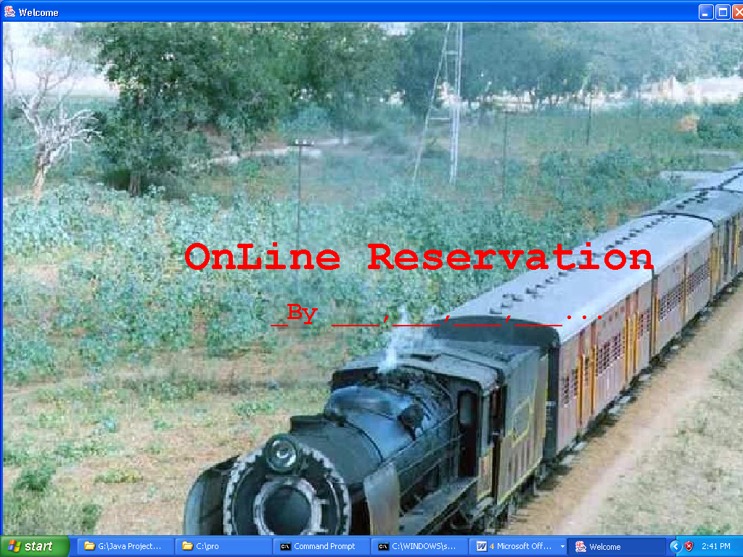

Login Screen

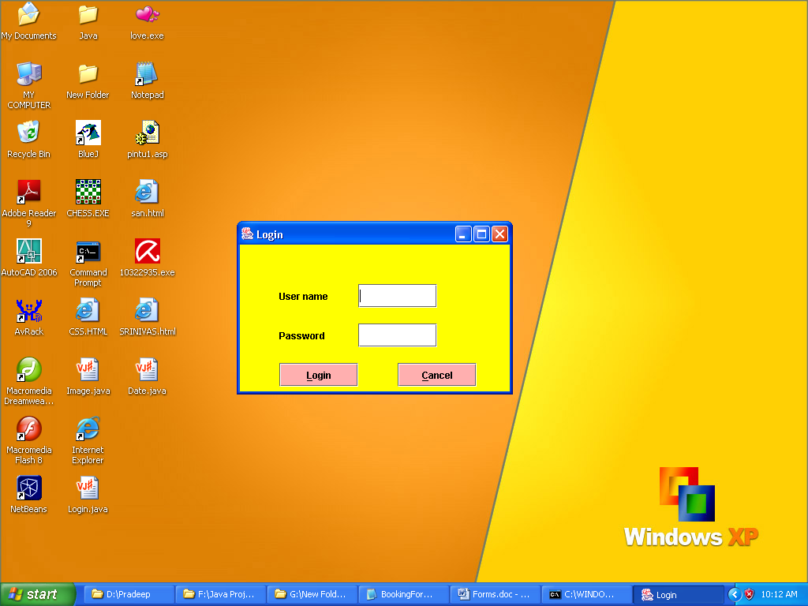

Main Screen

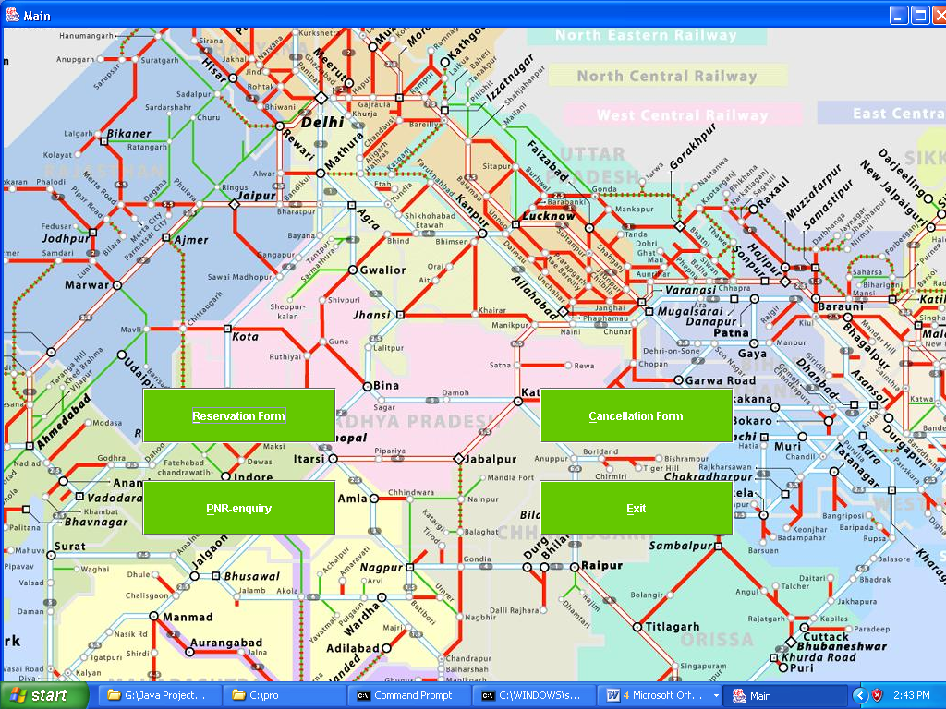
Reservation Form

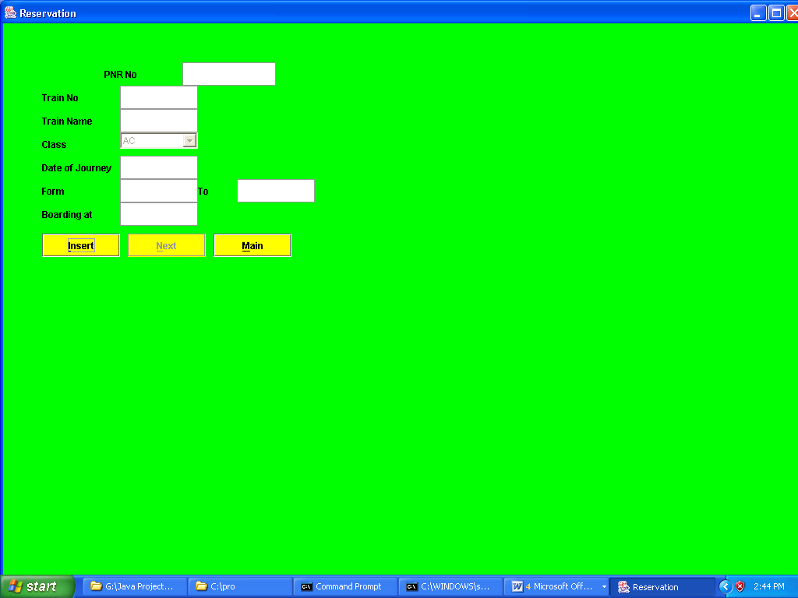
Passenger Form

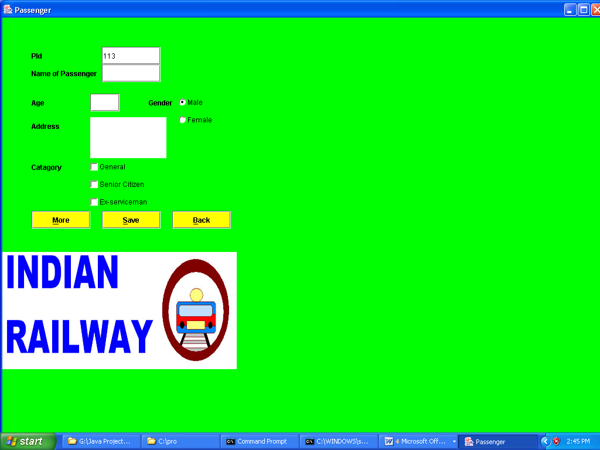
Enquiry Form

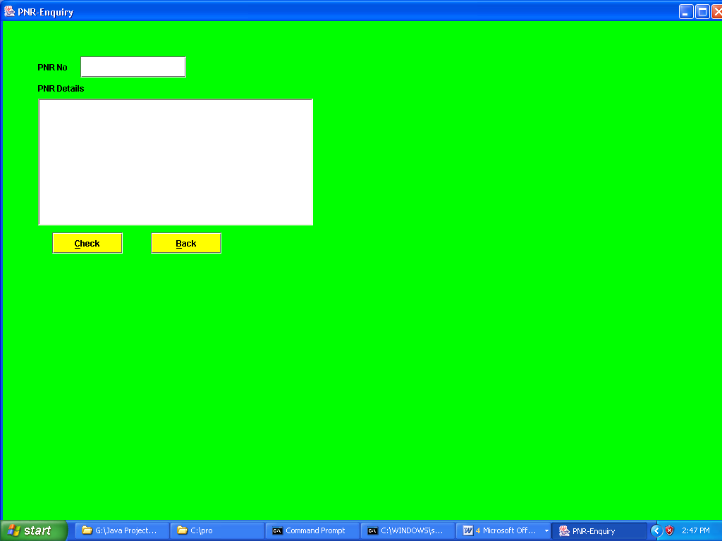

Cancellation Form

